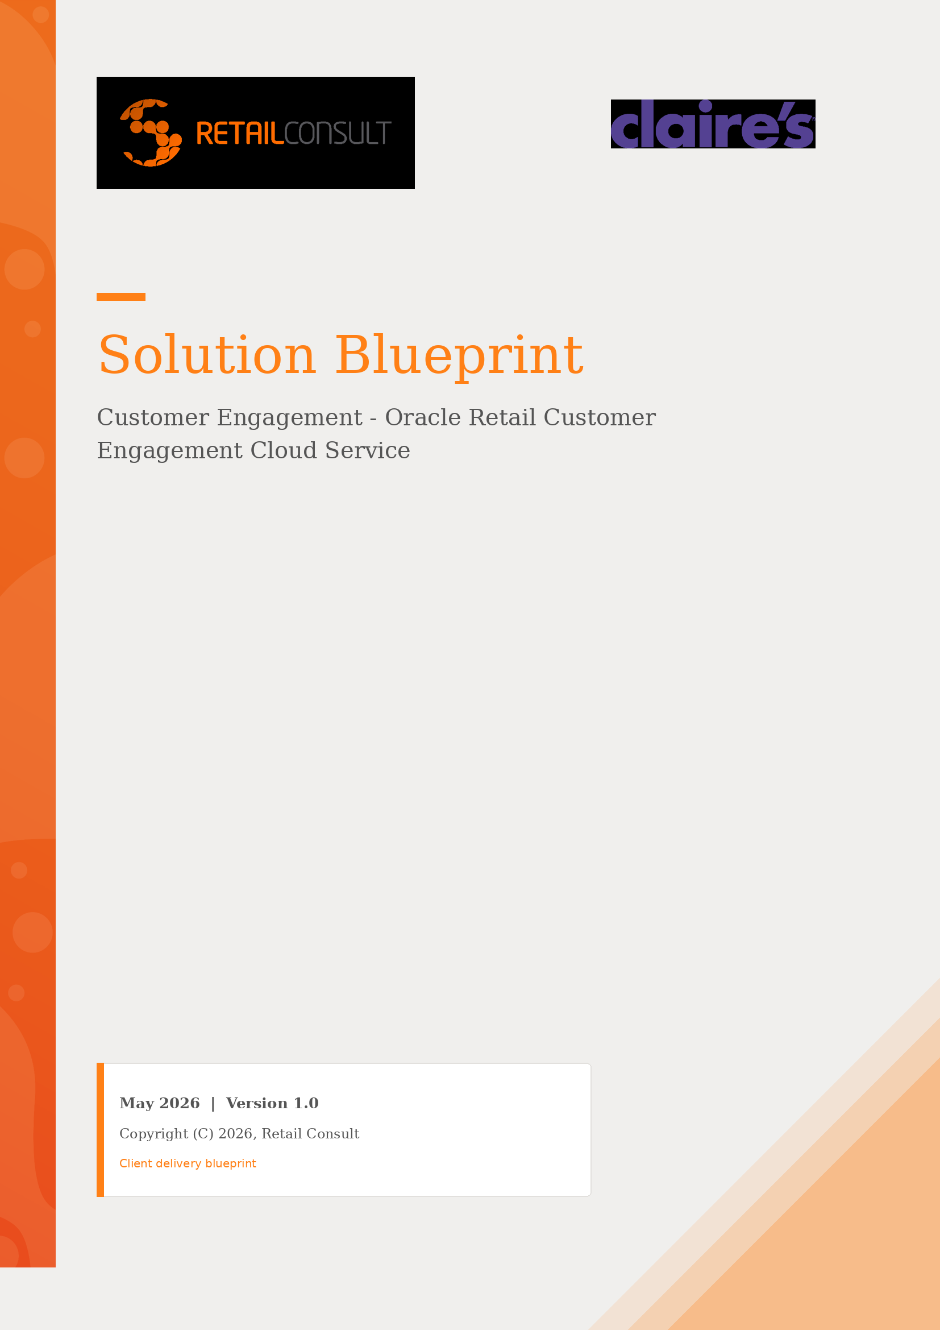

Disclaimer
This document in any form, software or printed matter, contains proprietary information that is the exclusive property of Retail Consult, and is not part of your license agreement, nor can it be incorporated into any contractual agreement with Retail Consult or its subsidiaries or affiliates. Your access to and use of this document is subject to the terms and conditions of your Retail Consult service agreement, which has been executed and with which you agree to comply. This document and information contained herein may not be disclosed, copied, reproduced or distributed to anyone outside Retail Consult without prior written consent of Retail Consult.
This document is intended solely for informational purposes, and it is not a commitment to deliver any material, code, or functionality, and should not be relied upon in making purchasing decisions. The development, release, and timing of any features or functionalities described in this document remains at the sole discretion of Retail Consult.

Change Control
Date | Version | Author | Review
27/05/2026 | 1.0 | Retail Consult | Initial Version

Table of Contents

Disclaimer
Change Control
Document Legend
Customer Engagement
1. Customers & Segmentation
1.1 Customer Dashboard
1.2 Customer Profile & Information
1.3 Activity & Purchase Profile
1.4 Loyalty Visibility
1.5 Customer Segmentation
1.6 Stratified Segments
2. Promotions & Offers
2.1 Campaign & Promotion Management
2.2 Promotion Types
2.3 Offers & Discount Structures
2.4 Coupons
2.5 Targeted & Personalized Promotions
2.6 Promotion & Offer Scorecards
3. Loyalty & Awards
3.1 Loyalty Program & Levels
3.2 Issue Rules — Earning Points
3.3 Marketing Engagement Points
3.4 Movement Rules — Tier Progression
3.5 Awards & Rewards
3.6 Returns & Point Deduction
Open Points & Decisions Tracker
Appendix
Glossary

Document Legend
Throughout this document, important pieces of information are highlighted using the following coloured callout boxes:
R.0: Requirements identified are highlighted in blue.

D.0: Decisions taken are highlighted in orange.

A.0: Assumptions made are highlighted in green.

Customer Engagement
Oracle Retail Customer Engagement Cloud Service (ORCE) is the customer-centric foundation of the Oracle Retail suite. It centralises customer master data, provides a 360° customer dashboard for store associates and back-office teams, and supports a configurable engine for customer segmentation, marketing promotions, offers, coupons, loyalty programmes and awards.
This blueprint describes how Claire's will implement ORCE across three main areas: Customers & Segmentation (Chapter 1), Promotions & Offers (Chapter 2) and Loyalty & Awards (Chapter 3). For each area, the document explains the relevant ORCE capabilities, references the corresponding User Guide sections, and captures the project decisions, assumptions and requirements that shape Claire's implementation.

1. Customers & Segmentation
The Customers & Segmentation area provides the foundation for understanding customer behaviour, managing customer information and grouping customers for targeted marketing and loyalty activities. It centralises the customer record, exposes a 360° customer dashboard, and supports unstratified and stratified segments as well as personal lists.

1.1 Customer Dashboard
The Customer Dashboard is the central point of contact in ORCE for managing customer information. It provides a single 360° view of an individual customer, consolidating profile, activity, loyalty and purchase data into one screen. The dashboard is reached from Customer Search and supports common operational actions such as view, edit, add to Personal List and create appointment.
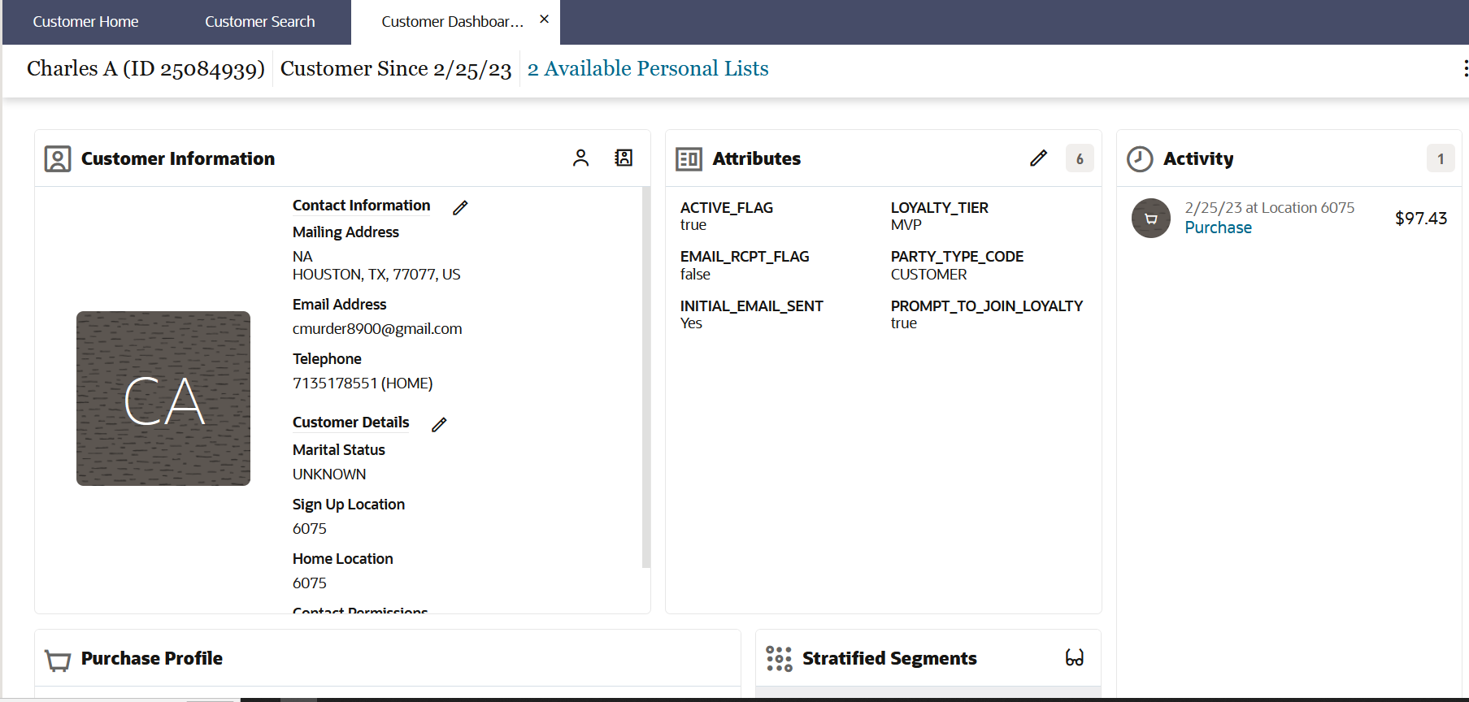
Figure 1 — Customer Dashboard — the consolidated 360° view in ORCE
The dashboard is organised in panels that surface different facets of the customer:
- Customer Information and Attributes
- Activity timeline — recent transactions and tasks
- Purchase Profile — purchase pattern by revenue centre and department
- Cards, Loyalty Programs, Awards, Offers and Promotions
- Segments and Stratified Segments
- Customer Household, Notes and Tasks
A.1: Store associates will use the Customer Dashboard as the primary clienteling screen across stores in the USA and Canada.

R.1: A single 360° customer view must be available to associates and back-office users.

D.1: Dashboard panels visibility per user role to be aligned with Claire's security model.

1.2 Customer Profile & Information
A customer record stores the core information held for each customer, including contact data (name, addresses, phone numbers, email), demographics, language and communication preferences (email/SMS/mail opt-in), customer class and prospect indicators, customer image and household relationships.
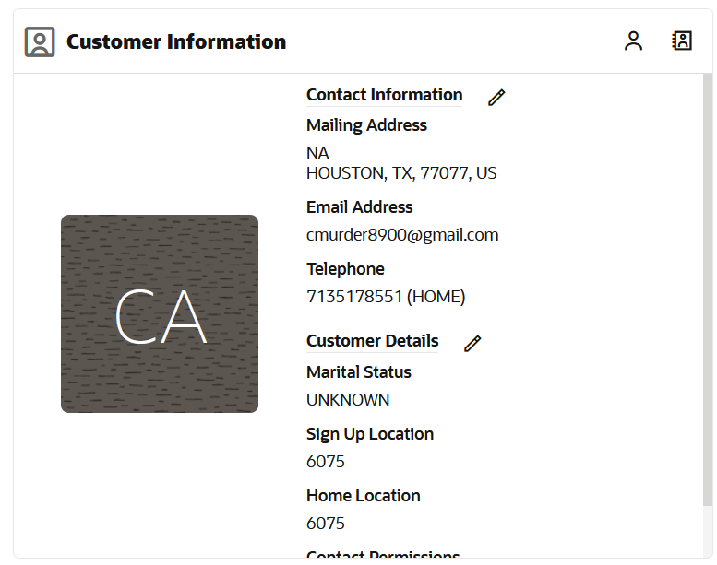
Figure 2 — Customer Information panel — profile, contact data and preferences
Customer maintenance covers add, edit, view, delete and customer merge actions, with field-level validation rules applied at creation. Configurable extended Customer Attributes (string, logical, date) allow Claire's to capture additional data points beyond the standard fields.
A.2: The customer master is created and maintained primarily through POS, with online sign-up adding additional records.

R.2: Capture contact data, communication preferences and consent (email / SMS / mail) for every customer.

D.2: Customer merge strategy and data-quality ownership to be defined with the marketing team.

1.3 Activity & Purchase Profile
The Customer Dashboard surfaces the customer's transactional history. The Activity panel shows a timeline of recent transactions and customer activities with drill-down to the full purchase history. The Purchase Profile shows a multi-year bar chart of purchase pattern by revenue centre / department, lifetime spend, total transaction count and return percentage.
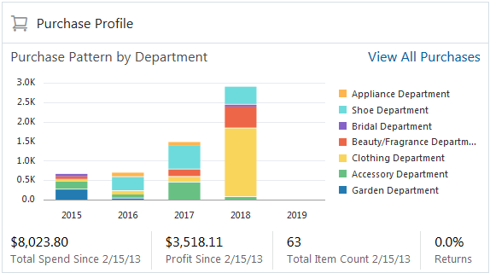
Figure 3 — Purchase Profile — purchase pattern by department over a rolling multi-year view
A.3: Transaction history is fed to ORCE from POS in near real time via the POSLog integration.

R.3: Purchase profile and return percentage visible at customer level for clienteling and segmentation.

D.3: Required history retention period for the purchase profile to be defined.

1.4 Loyalty Visibility
The Customer Dashboard exposes the customer's loyalty cards and programs. The Cards & Programs panel lists every loyalty card the customer has, with program, level and current points balance per card. Multiple loyalty programs are supported for the same customer (USA and Canada operate as separate loyalty programs in ORCE).
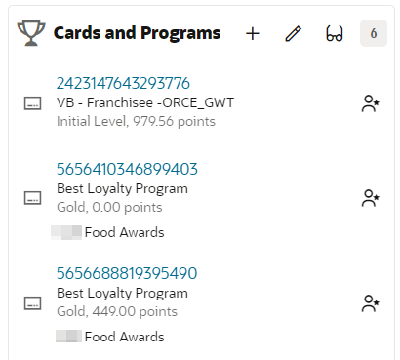
Figure 4 — Cards and Programs panel — loyalty cards, level and points balance
Transaction-linked loyalty activities (points issued or redeemed) are shown in the activity panel. The Award accounts panel lists coupons, e-awards and award certificates issued to the customer. Offers and promotion eligibility are visible directly on the dashboard. Loyalty returns are handled via the system property Process Loyalty Returns and the Verified Return Actions configuration (see Chapter 3).
D.4: USA and Canada operate as separate loyalty programs sharing the same design (levels, rules, awards).

R.4: Points balance, level and awards visible on the Customer Dashboard; point deduction applied on verified returns.

1.5 Customer Segmentation
Customer segmentation in ORCE groups customers using configurable business criteria. Segments are used for marketing, loyalty, personalization and reporting, and can be built either Unstratified (a flat list) or Stratified (split into strata / bands). Personal Lists are manually maintained lists curated by store associates or marketing.
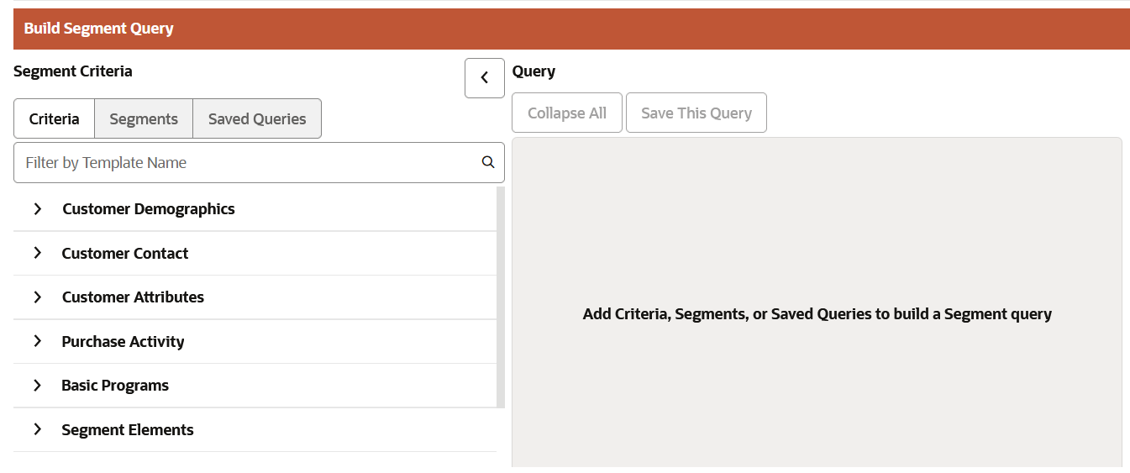
Figure 5 — Build Segment Query — segment criteria categories in ORCE
Segments are built in the Create Segment Wizard. The wizard offers nine Segment Query categories — Customer Demographics, Customer Contact, Customer Attributes, Purchase Activity, Basic Programs, Segment Elements, Promotion Activity, Strategic Segments and Loyalty Segments — providing more than seventy pre-built segment query templates.
Segments can drive campaign and award eligibility; they are attached to promotions to filter who receives the promotion. Refresh frequency is controlled per segment (segment refresh batch).
R.5: Segmentation by tier, sign-up store, products purchased (Ear Piercing SKU), rewards held, recency of engagement.

D.5: Segments are owned and maintained by the marketing team.

A.4: Segment refresh runs on a defined schedule (typically daily) to keep populations current.

R.6: Bestie status segmentation: customer reaches Bestie by net spend (not points). Native ORCE Movement Rules evaluate points only, so net-spend qualification is computed externally and pushed to ORCE via web service (see Chapter 3).

1.6 Stratified Segments
Stratified segments divide customers into levels or strata based on a metric. Range and N-Tile stratification models are supported, with Strata Type of Customer, Loyalty or Transaction. The Strata Query step is available in the wizard for Loyalty or Transaction strata types only.
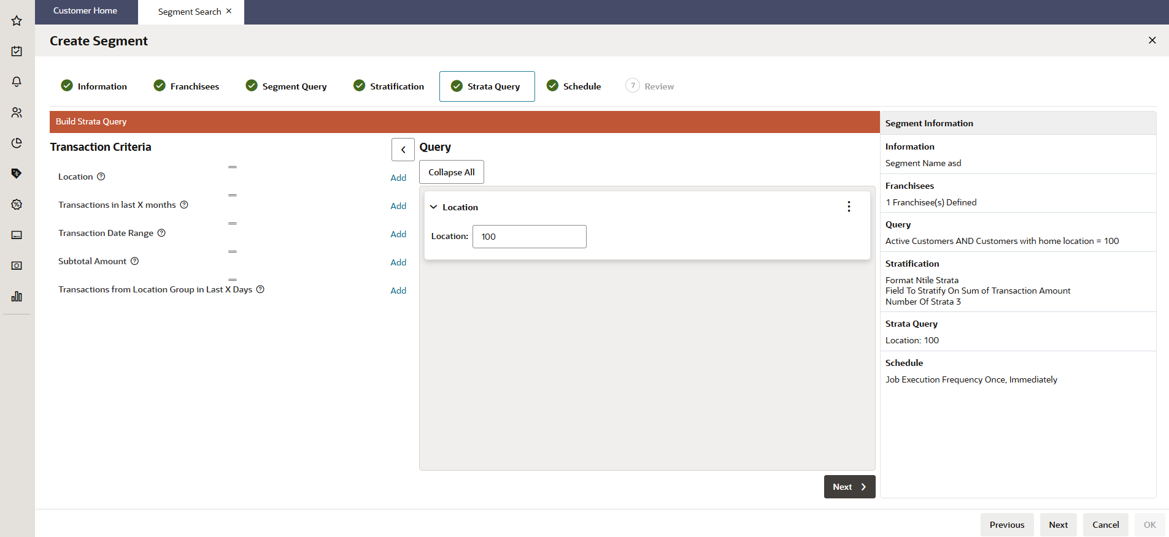
Figure 6 — Create Segment — the Strata Query step for stratified segments
Stratified segments are useful for VIP tiering, spend-band analysis and differentiated customer treatment. Strata are visualised on the Customer Dashboard with gauges and charts, and N-Tile / Range Strata reports are available.
A.5: Stratified segments will be used for VIP tiering and spend-band analysis to support targeted campaigns.

D.6: Strata boundaries and refresh frequency to be defined per segment use case.

2. Promotions & Offers
The Promotions & Offers area manages all marketing offers, discounts, coupons and bounceback campaigns issued to customers. It is organised around three concepts — Campaign, Promotion and Offer — and supports a wide catalogue of promotion types and discount mechanics, with audience targeting and full performance scorecards.

2.1 Campaign & Promotion Management
Marketing activity in ORCE is organised through Campaigns and Promotions. A promotion always belongs to a campaign, either auto-created or selected from existing campaigns. Each promotion has a type, a validity period, optionally an audience, and one or more offers.
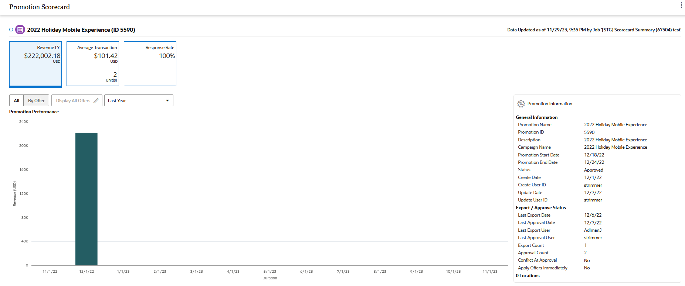
Figure 7 — Promotion Scorecard — a promotion within its campaign
Promotions are managed from the Campaign Task area. The Promotion Search filters by ID, campaign, type and status. The lifecycle is controlled through statuses Saved, Approved, Conflict, Clear and Terminated, with built-in conflict detection that flags overlapping promotions on the same items or locations.
A.6: Campaigns and promotions are managed by the marketing team in ORCE.

R.7: Promotions structured by campaign, with a controlled approval workflow and clear status lifecycle.

D.7: Promotion approval workflow and roles to be defined.

2.2 Promotion Types
ORCE supports eight promotion types, each designed for a specific marketing scenario:
- Coupon — distributes offers applied through a coupon code (serialized or non-serialized).
- Product — applies an offer directly to items or transactions at POS.
- Message — delivers a marketing message without an associated discount.
- Award — issues entitlement coupons or e-awards to members of an Award Program (no offer required).
- Points for Purchase — awards loyalty points for qualifying purchases during the campaign period.
- Points for Marketing Engagements — awards points for non-purchase activities.
- Points — issues bonus loyalty points to specific program members.
- Bounceback — a qualifying purchase triggers a follow-up offer or coupon for the next visit.
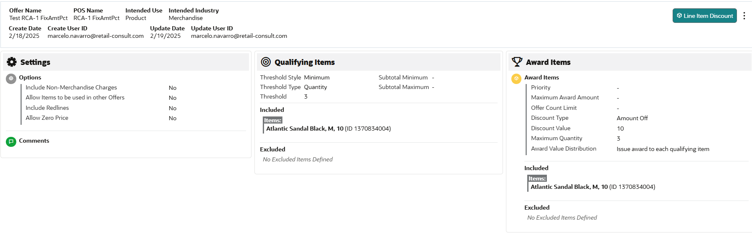
Figure 8 — Offer setup — Settings, Qualifying Items and Award Items
A.7: Discounts are applied at POS through ORCE promotions integrated with Xstore.

R.8: Support for coupon, product, award and loyalty-driven promotion types.

D.8: Promotion types in scope for go-live to be confirmed with marketing.

2.3 Offers & Discount Structures
An Offer defines the actual incentive applied; a promotion includes one or more offers. ORCE supports a comprehensive catalogue of offer types: Transaction Discount, Line Item Discount, Fixed Quantity/Price, Kit, Gift with Purchase, Buy X Get X, Buy X Get Y, Tiered Discount, Buy X Get Points, Marketing Engagements and Bounceback Trigger.
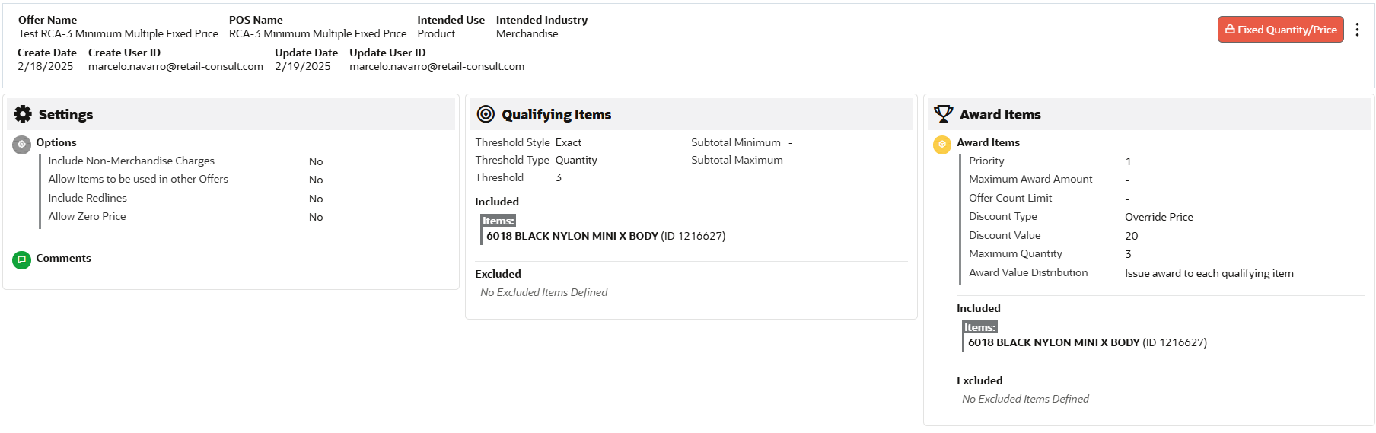
Figure 9 — Offer detail — a Fixed Quantity / Price discount structure
Each offer is structured in three panels — Settings, Qualifying Items, Award Items — controlling options (non-merchandise charges, zero price), the items that trigger the offer, and the items or discount that are applied. Discount types include Amount Off, Percent Off and Override Price.
A.8: Item and merchandise hierarchy is available to define qualifying items and exclusions.

R.9: Offer types to cover amount-off, percent-off, override-price and gift-with-purchase scenarios.

D.9: Discount structures required for launch campaigns to be confirmed.

2.4 Coupons
A Coupon Promotion delivers offers through coupon codes. The associated offer's Intended Use is set to Coupon. Coupons are validated and redeemed at POS and ecommerce. Additional coupon codes can be generated against the same promotion.
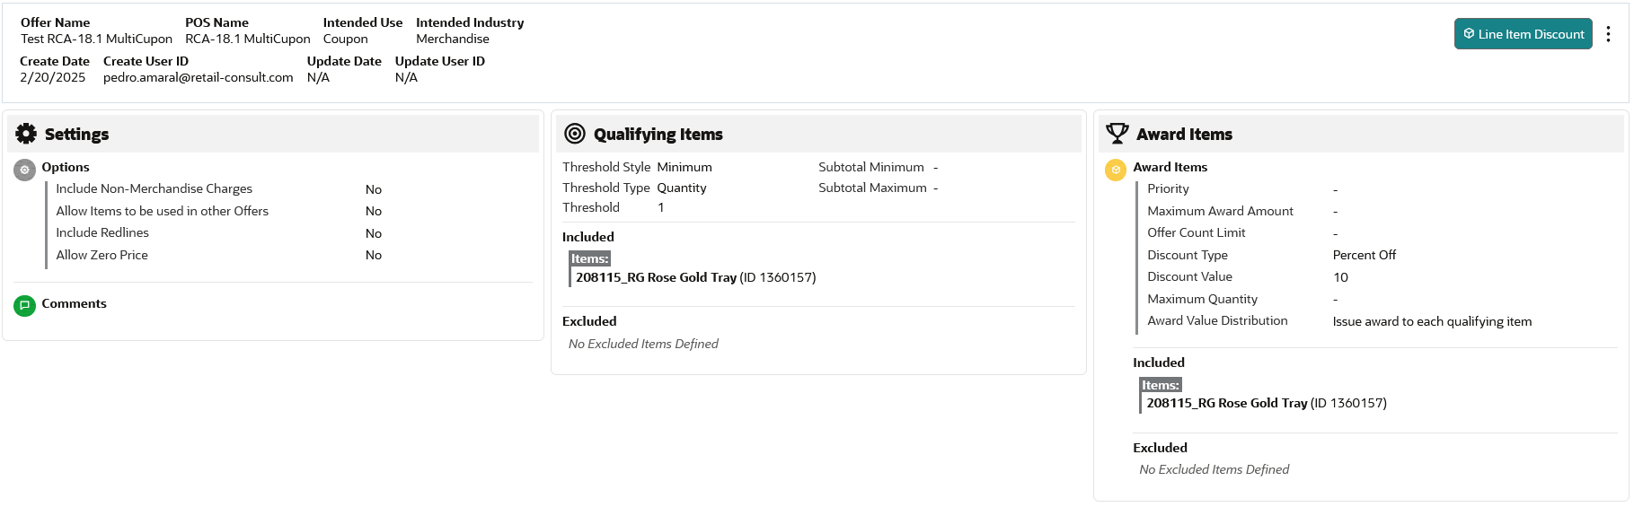
Figure 10 — Coupon offer — an offer with Intended Use set to Coupon
ORCE supports two coupon modes: Serialized (unique single-use serial-numbered codes generated in bulk) and Non-Serialized (one shared, multi-use code such as SHOE20). Serialization is controlled by the Serialized Coupon Enabled flag in system configuration. Redemption and usage are tracked per coupon.
A.9: Coupons are issued digitally and redeemed at POS and ecommerce.

R.10: Support for both serialized (single-use) and non-serialized coupon codes.

D.10: Coupon generation volumes, distribution channels and expiry rules to be defined per campaign.

2.5 Targeted & Personalized Promotions
Promotions can be untargeted (all customers) or targeted to an Audience. Audience Definition is built from segments and customer lists. Audience rules support Exclusive or Non-exclusive audience groups, and the selection method can be Static or Dynamic.
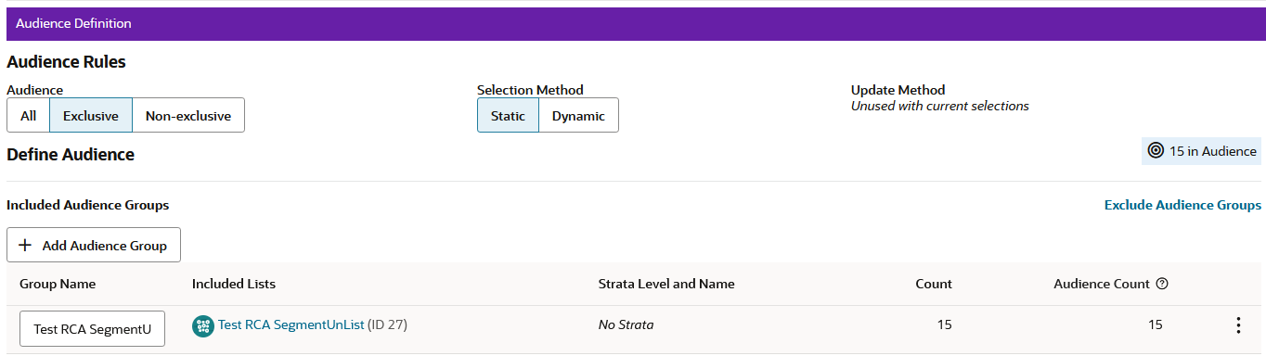
Figure 11 — Audience Definition — targeting a promotion with segments
Personalization is achieved through segments (driving who receives each promotion), Bounceback promotions (reacting to a customer's own purchase behaviour) and Award promotions (delivering customer-specific entitlements). Promotion audience and response are tracked on scorecards.
A.10: Customer segments are maintained continuously and made available for promotion targeting.

R.11: Promotions targeted to segments, with support for exclusive and dynamic audiences.

D.11: Personalization scope and audience refresh frequency to be agreed.

2.6 Promotion & Offer Scorecards
Two scorecards measure promotion performance. The Promotion Scorecard measures a promotion over its life with metrics Revenue, Average Transaction and Response Rate, and a Promotion Performance chart over the selected duration.
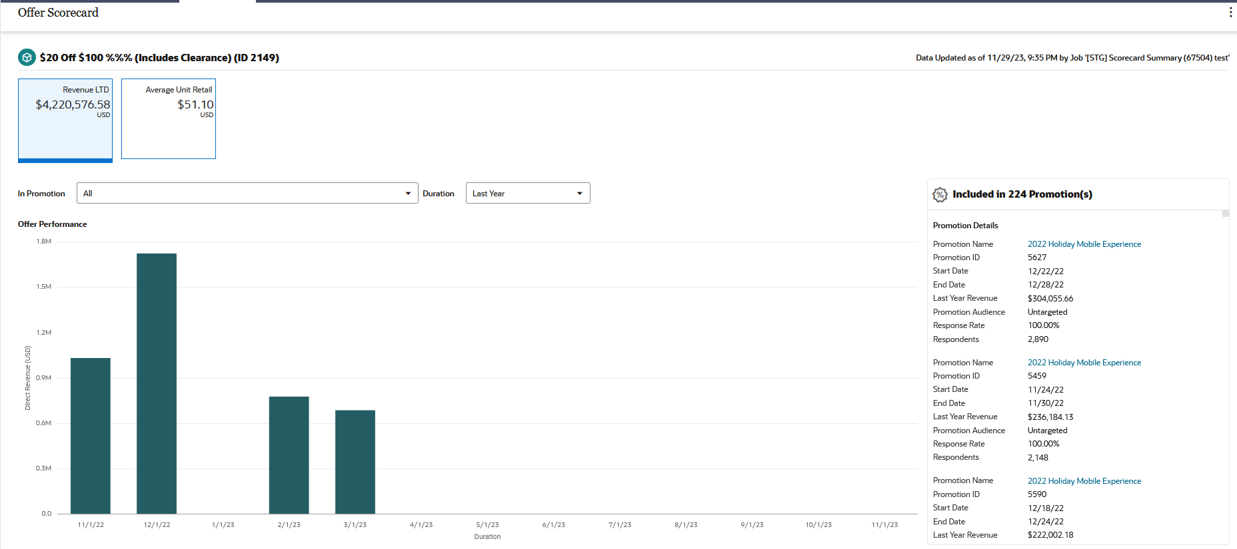
Figure 12 — Offer Scorecard — offer performance across promotions
The Offer Scorecard measures the performance of an individual offer, with Revenue LTD, Average Unit Retail and a list of every promotion the offer is included in, with respondents and response rate per promotion.
A.11: Scorecard summary jobs run on a defined schedule to keep performance data current.

R.12: Promotion and offer performance visible to marketing for analysis and decision support.

D.12: Reporting KPIs, cadence and ownership to be defined with the marketing team.

3. Loyalty & Awards
The Loyalty & Awards area manages Claire's loyalty programme — tiers, points earning rules, level progression, awards and returns handling. ORCE supports a configurable loyalty engine with Issue Rules (how points are earned), Movement Rules (how customers progress between levels), Award Rules (how awards are issued) and native loyalty returns handling.

3.1 Loyalty Program & Levels
Claire's operates a single loyalty programme per country: separate ORCE Loyalty Programs are configured for USA and Canada, with the same design (levels, rules, awards). Within each programme there are two tiers: Friend (Level 1, entry) and Bestie (Level 2, upper). All members start as Friend; Bestie is unlocked through qualification (see Movement Rules).
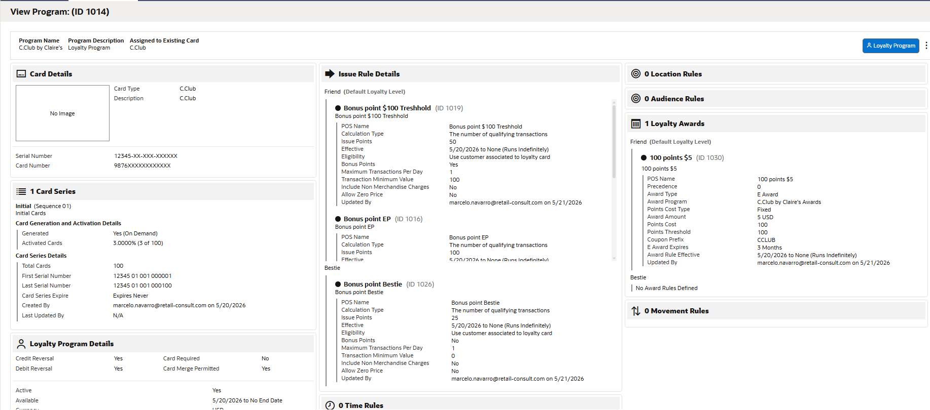
Figure 13 — Loyalty Program & Levels — program and tier setup
The customer's loyalty level is held on the Loyalty Account and shown on the Customer Dashboard. Manual level changes are possible through the Change Level action, controlled by role-based permissions. The level is exposed via web service to POS and ecommerce so they can apply tier-specific treatments.
D.13: Only two tiers will be used: Friend (Level 1) and Bestie (Level 2).

A.12: Each country has its own loyalty programme (USA, Canada). Quebec is currently out of scope.

R.13: Tier level visible on the Customer Dashboard and exposed via web service to POS and ecom.

3.2 Issue Rules — Earning Points
Issue Rules define how customers earn points. Claire's base rule grants 50 points per qualifying purchase, limited to 1 qualifying purchase per day per customer (employees: 1 per week), with a positive net spend requirement. Bestie tier earns an additional 25 bonus points per qualifying transaction.
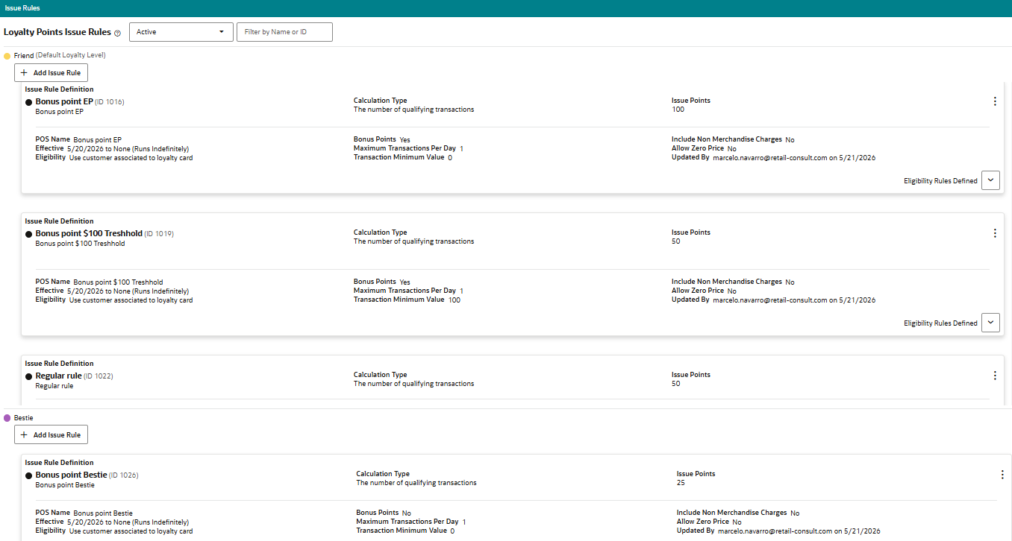
Figure 14 — Issue Rule — points per qualifying transaction
Additional Issue Rules drive bonus campaigns: $100 purchase bonus (+50 points, US/CA only, configured with Transaction Minimum Value = 100), Piercing SKU bonus (+100 points, via an Item Rule pointing to the piercing service SKU), and time-limited Double Points / Triple Points campaigns. Item Rules also allow inclusion or exclusion of specific SKUs.
D.14: Loyalty programme uses points-per-purchase logic (flat 50 points per qualifying transaction) rather than spend-based earning.

A.13: Both levels earn 50 points per qualifying purchase; Bestie earns an additional 25 points bonus per qualifying transaction.

R.14: $100 purchase bonus (+50 points, US/CA) and piercing SKU bonus (+100 points) must be configured.

D.15: Gift card tender exclusion from points eligibility requires integration logic — not native to the ORCE points engine.

3.3 Marketing Engagement Points
Marketing Engagement Points reward customers for non-purchase activities. They are configured as Issue Rules with Calculation Type = Number of marketing engagements, with Rule Count Limit = 1 (one-time per member). Triggers come from claires.com or the app via the Events API.
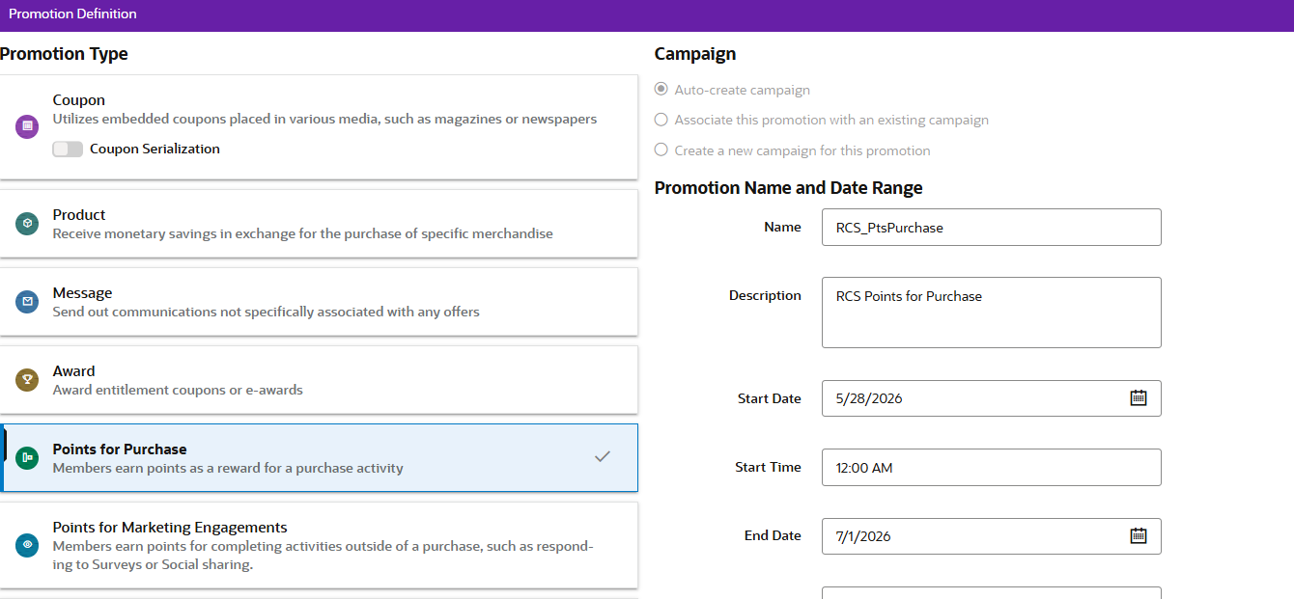
Figure 15 — Points for Purchase promotion — base for non-purchase engagement variants
Claire's engagement catalogue:
- Birthday information provided: +15 points
- "Who are you shopping for" provided: +15 points
- Address provided: +15 points
- TikTok follow: +10 points
- Facebook follow: +10 points
- Instagram follow: +10 points
A.14: Engagement points are triggered by claires.com / app via the Events API; each engagement is one-time per member.

R.15: Marketing engagement points: 15 points for birthday / who-are-you-shopping-for / address; 10 points for TikTok / Facebook / Instagram.

D.16: Engagement event payload contract and trigger flows to be confirmed with the integration team.

3.4 Movement Rules — Tier Progression
Movement Rules govern how customers progress between loyalty levels. They support promotion, sustain and demotion logic, with test types over YTD Points, LTD Points, Points Since Last Level Move, Average Points/Month and Time Period.
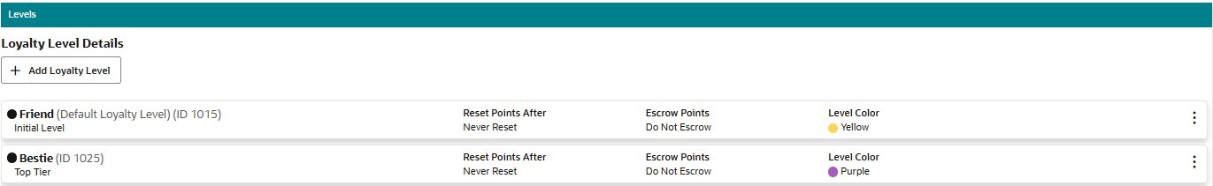
Figure 16 — Loyalty Levels — Friend and Bestie tier configuration
Claire's Bestie qualification is based on $100 annual net spend (calendar year). Because ORCE's native Movement Rules evaluate points (not spend), the net-spend calculation is performed externally by Inte Q daily, and the level change is pushed to ORCE via web service (ActivityImport with type Change Level). Bestie status is held in the qualification year and the full following year, with requalification required during Year 2 to retain Bestie in Year 3. This is modelled in ORCE with a Sustain Movement Rule using Extend Sustain Period.
D.17: Bestie qualified by $100 net annual spend (calendar year). Spend-based qualification computed by Inte Q and pushed to ORCE.

A.15: Inte Q calculates annual net spend daily and triggers the Change Level via the ActivityImport web service.

R.16: Bestie status retained for the rest of Year 1 and full Year 2; requalification during Year 2 grants Bestie in Year 3.

D.18: Net-spend exclusions (discounts, shipping, taxes other than VAT, gift card redemptions) to be confirmed.

3.5 Awards & Rewards
Awards are issued by Award Rules within the loyalty programme or by Award Promotions. Claire's standard reward is $5 at every 100 points, configured as an Award Rule with Points Threshold = 100 and Points Cost = 100, issuing an E-Award certificate of $5.00 from the C.Club Award Program. The reward sweep runs on schedule after a 5-day business rule.
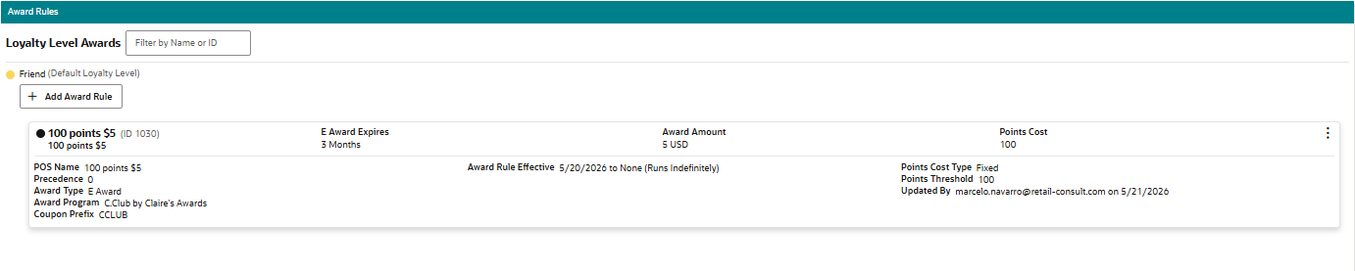
Figure 17 — Award Rule — $5 E-Award at every 100 points
Special awards complement the standard reward:
- Anytime Reward: a $5 bonus reward that members request on claires.com. Level 1 = 1 per year; Level 2 = 2 per year. On-demand issuance via web service. Reset on January 1st.
- Birthday reward: $5 OFF (Friend) / $10 OFF (Bestie) coupon, delivered by email during the birthday month.
- Free Gift award on Bestie tier-up.
- Free Earrings for a Year benefit (Bestie tier).
D.19: $5 award issued at every 100 points; Anytime Reward $5 (Friend: 1/year; Bestie: 2/year).

A.16: Birthday discount communications are issued by the ESP (SFMC); ORCE supplies the eligibility trigger via the Birthday Time Rule and the coupon for redemption.

R.17: Free Gift coupon issued automatically on Bestie tier-up; Free Earrings for a Year benefit available to Bestie tier.

A.17: All annual benefits and bonus rewards reset on January 1st of each year.

3.6 Returns & Point Deduction
ORCE processes loyalty returns natively via the system property Process Loyalty Returns. The Verified Return Actions configuration controls deduction logic, with options DEDUCT_NO_POINTS, DEDUCT_POINTS_ORIGINAL_PURCHASER and DEDUCT_POINTS_RETURNING_CUSTOMER. The Negative Balance Allowed flag on the loyalty level permits negative point balances when deductions exceed available points.
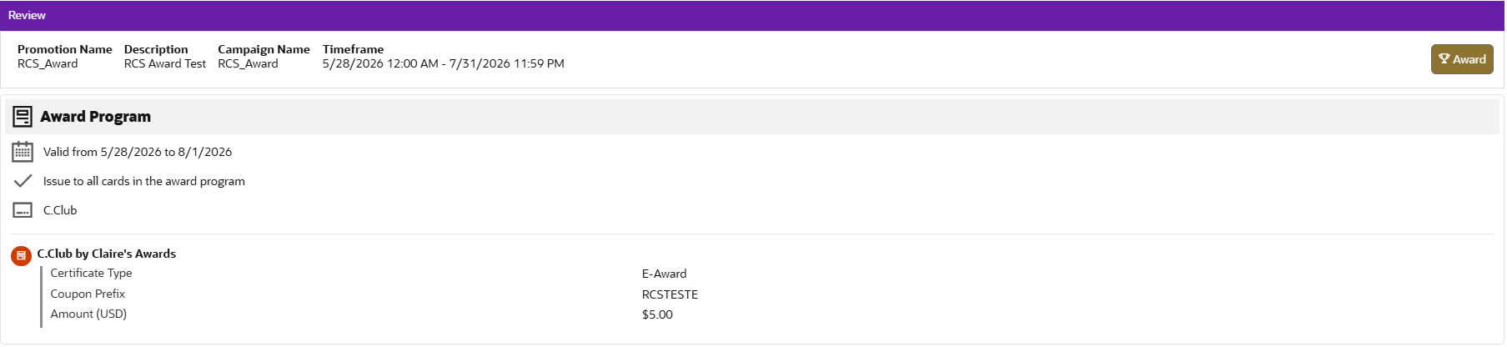
Figure 18 — Award Promotion review — issue from an Award Program
Claire's business rule is that points are deducted only if the original transaction fully nets to zero (i.e., a full return); partial returns leave points intact. This differs from the standard ORCE per-item reversal and is implemented by Inte Q logic that deducts 50 base points (and 25 bonus points for Bestie) only when a return brings the original transaction's net to zero. Level demotion on returns is not applied (no demotion Movement Rule is configured against return activity).
D.20: Verified Return Actions configured to deduct points from the returning customer.

A.18: Inte Q deducts the 50 base points (and 25 bonus points for Bestie) only when a return brings the original transaction net to zero.

R.18: Standard ORCE per-item reversal must be customised (or handled in Inte Q) to match Claire's full-return rule.

D.21: Behaviour for partial returns and returns crossing year-end requalification to be defined.

Open Points & Decisions Tracker
The following table consolidates the open points and decisions identified throughout this document that still require confirmation. Each entry references the originating callout in the body of the blueprint.
ID | Area | Ref | Description | Status
OP-01 | Customers & Segmentation | D.1 | Dashboard panels visibility per user role to be aligned with security model. | Open
OP-02 | Customers & Segmentation | D.2 | Customer merge strategy and data-quality ownership to be defined. | Open
OP-03 | Customers & Segmentation | D.3 | Required history retention period for the purchase profile to be defined. | Open
OP-04 | Customers & Segmentation | D.6 | Strata boundaries and refresh frequency to be defined per use case. | Open
OP-05 | Promotions & Offers | D.7 | Promotion approval workflow and roles to be defined. | Open
OP-06 | Promotions & Offers | D.8 | Promotion types in scope for go-live to be confirmed with marketing. | Open
OP-07 | Promotions & Offers | D.9 | Discount structures required for launch campaigns to be confirmed. | Open
OP-08 | Promotions & Offers | D.10 | Coupon volumes, channels and expiry rules to be defined per campaign. | Open
OP-09 | Promotions & Offers | D.11 | Personalization scope and audience refresh frequency to be agreed. | Open
OP-10 | Promotions & Offers | D.12 | Reporting KPIs, cadence and ownership to be defined. | Open
OP-11 | Loyalty & Awards | D.15 | Gift card tender exclusion logic — integration design required. | Open
OP-12 | Loyalty & Awards | D.16 | Engagement event payload contract and trigger flows to be confirmed. | Open
OP-13 | Loyalty & Awards | D.18 | Net-spend exclusions (discounts, shipping, taxes, gift cards) to be confirmed. | Open
OP-14 | Loyalty & Awards | D.21 | Behaviour for partial returns and returns crossing year-end requalification. | Open
OP-15 | Loyalty & Awards | A.12 | Confirm Quebec scope (currently out of scope). | Open

Appendix
Reference documentation used as the basis for this Solution Blueprint:
- Oracle Retail Customer Engagement Cloud Service — User Guide (release 25.0.101.0)
- Oracle Retail Customer Engagement Cloud Service — Implementation Guide (release 25.0.101.0)
- Oracle Retail Customer Engagement Cloud Service — Batch Processing & Web Services Guide (release 25.0.101.0)
- Claire's Loyalty Relaunch Requirements 2026 (client BRD)
- Claire's ORCE Fit Analysis v1.2
- Claire's ORCE ScoreCard

Glossary
Award Program — A container in the loyalty module that holds awards (coupons, e-awards, certificates) and the rules that issue them.
Award Rule — Configuration inside a loyalty program that issues an award when defined conditions are met (e.g., points threshold reached).
Bestie — Claire's Level 2 loyalty tier. Members qualify based on annual net spend.
Bounceback — A promotion type that, on qualifying purchase, issues a follow-up offer or coupon for a later visit.
C.Club — Claire's Award Program used to issue the standard $5 E-Award.
Campaign — Top-level marketing container in ORCE. Holds one or more promotions.
Customer Dashboard — The 360° customer view in ORCE showing profile, activity, loyalty, segments and offers.
Customer Note Type — User-defined label for customer notes. List configured in the System Property CustomerNoteTypeCodes (max 20 types). Default: COMMENT.
Friend — Claire's Level 1 loyalty tier (entry level). All members start here.
Inte Q — Third-party loyalty integration partner that calculates net spend and triggers level changes via web service.
Issue Rule — Configuration inside a loyalty program that defines how customers earn points.
Movement Rule — Configuration inside a loyalty program that defines how customers progress between loyalty levels.
Offer — Defines the actual incentive applied. Promotions hold one or more offers.
ORCE — Oracle Retail Customer Engagement Cloud Service.
Personal List — A manually maintained list of customers.
Promotion — A marketing action attached to a campaign. Has a type, dates, audience and one or more offers.
Promotion Response Sync Import — ORCE batch that imports email response data (SENT/CLICK/OPEN/FAIL) from a marketing system such as Responsys. Creates Customer Notes for each event.
Segment — A grouping of customers built using business criteria. Can be unstratified (flat list) or stratified (split into bands).
Strata Query — Step in the Create Segment wizard available for Stratified segments with Strata Type Loyalty or Transaction.
Verified Return Actions — System property that controls how loyalty points are handled on a verified return.

